## 

**

***HackINSAN 2024***

***Project Report***

Mastermind | Madani IT Experts

Siti Safiah Damia binti Mohd Sarafiz (19)

Nur Ain Maisarah binti Abu bakar (19)

Mohamad Adam Zafri bin Zulbahari (19)

Amir Darwish bin Mohammad Yusuf (19)

## **Source of Inspiration**

Our motivation for choosing the concepts for our project came from our online research on GIS, which revealed that this type of system is a computer program that evaluates and presents data with a geographical reference. We have therefore connected the issue to the required desired aim. Our goal is to create a system that offers comprehensive data on the physical state of land affected by issues like landslides, sinkholes, pollution, and other issues. Our technology is highly appropriate for a client who wishes to purchase a house but needs to view the land's condition without physically visiting the construction site.

## **Project Overview**

LANDING PAGE

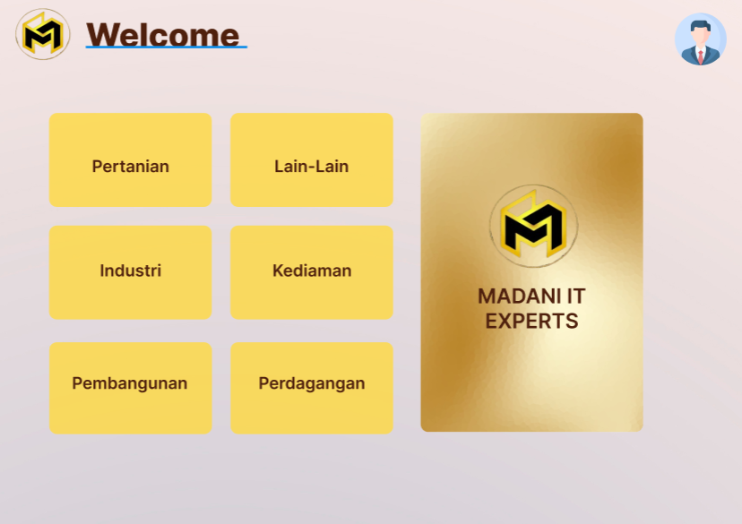

The moment our software/system is opened, the user (data analyst) will be in the landing page. The user will be here after the drones that is containing the data of a site, being brought in. In this page, there is 6 functional button and one emblem with a logo of MADANI IT EXPERTS.

1. Pertanian Button. When pressed, the user will be brought to another webpage specifically for extracting the data based on the drone input of the Pertanian area.
2. Lain-Lain Button. When pressed, the user will be brought to another webpage specifically for extracting the data based on the drone input of the other unspecified area.
3. Industri Button. When pressed, the user will be brought to another webpage specifically for extracting the data based on the drone input of the Industri area.
4. Kediaman Button. When pressed, the user will be brought to another webpage specifically for extracting the data based on the drone input of the Kediaman area.
5. Pembangunan Button. When pressed, the user will be brought to another webpage specifically for extracting the data based on the drone input of the Pembangunan area.
6. Perdagangan Button. When pressed, the user will be brought to another webpage specifically for extracting the data based on the drone input of the Perdagangan area.

EXTRACTION PAGES

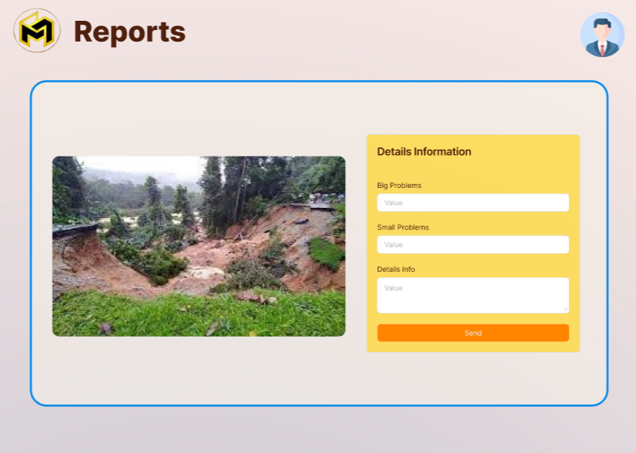

Right after the user pressed the button, the display of a video retrieved by the selected drone will appear, the user can fill out the problems form after analysing the video data right beside the form.

1. Words area to be filled with Huge problems that is detected by the data analyst.
2. Words area to be filled by small problems that is detected by the data analyst.
3. Words area that ica be filled with detail info about the area scouted.(environment, weather etc.
4. Submit Button. When pressed, data that has been filled inside the word area, will be converted into interesting and usefull reports by an AI tech.

EXTRACTION PAGES

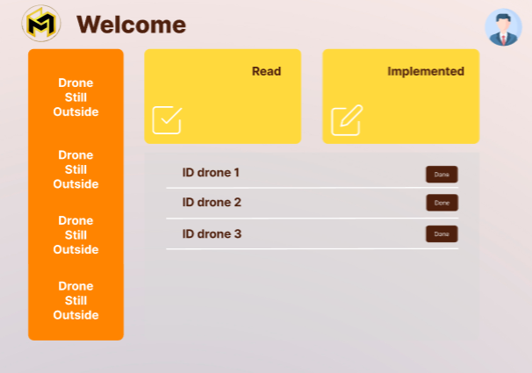

Right after the generate button is pressed, the user will be sent here.

1. The drone is still outside is a notification on how many drones are still there outside.
2. The list is for the drones that has been extracted the data. Will be submitted to the admin.
3. The “read” yellow box, is telling the user that the data uploaded from the drone list is read by the admin.
4. The “implemented” yellow box is telling the user that the data given is implemented in the website.

USER MODULE

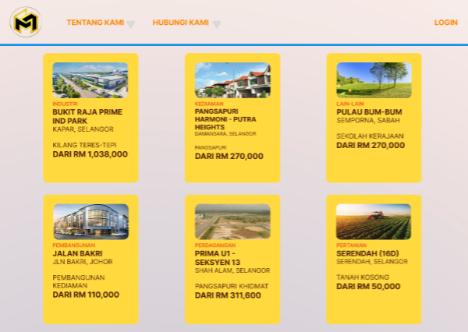

Right after the client accepted the link and visit our website.

1. There is 6 category of area that our drone covers, the user can choose each one that the client is interested in. each of the cards is functional and interactive.

USER MODULE

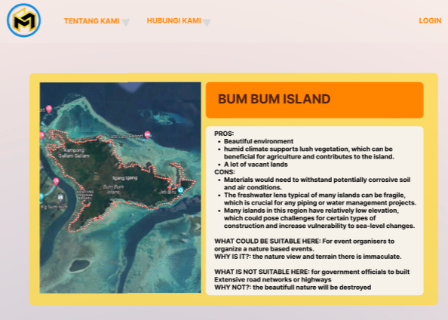

The user may choose and the chosen card is up

1. There is a video of the area interested, there is also a very detailed data about the area chosen to help hook the client.

## **Development Process**

Phases of the Software Development Life Cycle (SDLC) are used. Firstly, we establish the project's objectives, parameters, and assets during the planning stage. This includes risk management, resource allocation, project planning, and feasibility assessments. We then gathered and examined requirements from the internet for the Requirements Analysis phase in order to determine what the software must accomplish.

We develop the system architecture during the design phase, specifying its features and organization. Data flow modelling, database design, interface design, and system design are among the activities. The design specifications were completed during the implementation phase. The testing stage then verifies that the program satisfies the specifications and is error-free. Subsequently, implementing the software in a production environment and doing final testing comprise the Deployment step.

For our group structure, information gathering was done together. the designer part was held by Ain and also Amir. Meanwhile, part of the development phase was done by Adam. Safiah is the presenter for our group.

## **Challenges Encountered**

The problem encountered throughout the development of this system is that we have all experienced misunderstandings related to GIS. Initially based on the problem statements given, we want to develop a system where the system can help students who live in Cyberjaya to find the location of a place that is close to them. We changed our mind to change the project when a mentor came to us and compared our system with google maps. The mentor said that, why should users use our system if google maps is already available. After that, we have changed our mind to create a visual system report after doing research and understanding it more deeply.

## **Key Learnings**

There is a lot of knowledge that we have learned here, especially related to GIS. Previously, the system that was often known was like AI. GIS is not very familiar to all of us and we have done a lot of deep research. Additionally, this is one of the largest systems we have ever developed. A lot of knowledge about how we discuss and develop this system such as how to think and analyze.

## **Future Directions for Project**

The GIS-based Report Visualizer System has the potential to greatly influence a number of target groups, such as government agencies, event planners, and real estate brokers. By providing precise geographic data, the system helps government agencies make better decisions, especially in the area of urban planning. This results in more informed choices being made for infrastructure projects and city planning. Processes are streamlined, which speeds up project approval and implementation. Through real-time data, the system improves reaction efforts in disaster management, enabling prompt and precise emergency responses as well as better resource allocation during crises. By strengthening the capacity to monitor and safeguard natural resources, it facilitates environmental monitoring by making it easier to track regulatory compliance.

The Report Visualizer System has significant advantages for event planners as well. Precise design of event layouts and facilities is made possible by detailed site maps, which lower the possibility of mistakes and oversights and promote cost-effective management. The system's real-time monitoring features improve overall event efficiency by ensuring crowd safety and enabling prompt reactions to possible problems. Events are executed more smoothly as a consequence of enhanced logistical preparation and coordination, which further streamlines operations.

The method offers property agents a competitive advantage. Proper aerial photography adds value to real estate listings by raising their appeal to prospective purchasers and boosting sales. Better property management and upkeep are made possible by improved visualization tools, which also result in more effective property management procedures. Furthermore, the system offers useful planning insights that aid agents and developers in more successfully presenting possible projects to stakeholders and investors, increasing the likelihood of successful developments.